Munchkin co-op

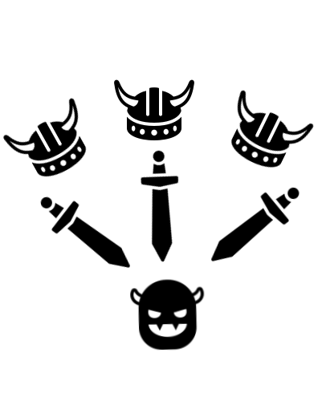

A teamplay idea by Jonathan F.M. Neels.
For the brilliant card game Munchkin by Steve Jackson.

Content

1. Intro 3
2. How to start 4
3. Choose a goal 5
4. How turns work 5
5. Clearing questions 6
6. Use the Double D (2 dimensional dice) 7

Icon source: https://icons8.com/icons
- Intro

Do you have a friend who is very competitive, obsessed by game rules or just plain ‘mean’?
Have you ever played a boardgame with him/her, like Monopoly, and realised on end of the evening you’re having an burn-out?
Did you ever dared playing Munchkin, your favorite game, with the menace?
Now there is a solution, a way to enjoy any Munchkin title (card game) in (relative) harmony.
Munchkin co-op to the rescue!

In this document we explain how Munchkin co-op works, with extra rulesets for veteran players (colored in red).

- How to start

Important:
If a rule isn’t written in this document, the standard rule in Munchkin counts. This can be the information on your Munchkin version instructions, or just simple the decision from the owner of the current card game.

- Every player receives three treasure cards and two door-cards on start
- The “dungeon” is shaped how the DM chooses. Default we take a rectangle with 5 rows and 5 columns.
Each tile consists of the following amount of door-cards:
playercount with one extra card (2 players= 3 cards, 4 players = 5 cards, …).
To make things fun, you can choose to place, instead of a series of door-cards,
one treasure.
Depending on the “goal” you choose,
place a boss on the end of the dungeon (just outside the roster).
The first step is in front of the roster (see image).
To make things more lively, you can choose to give each player a physical avatar
(a Macdonald’s toy, a crown cap, a figure from your demolished Monopoly game, …).
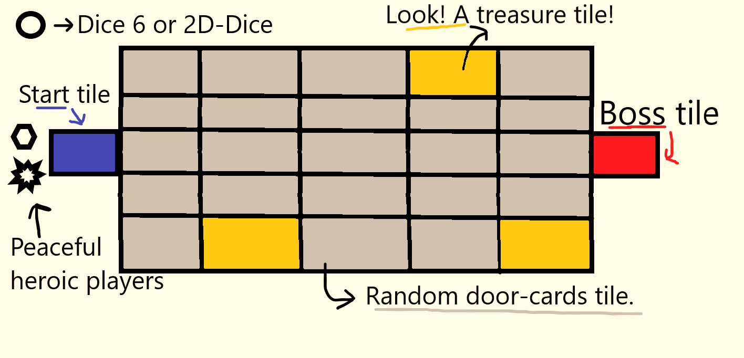

- Choose a goal
- Everybody reach level 10 (hard-mode: do this in 15 rounds)
- Defeat the end-boss (requires pr e- determined card at the end). It is a level 17, 18, 19 or higher mob from your game (chosen by the DM).
The other cards are random (and the count is based on the amount of players plus one).
(hard-mode: the boss has closed door cards next to it based on the amount of players plus two cards)
- Hard-mode: Kill ALL other players (Note: always is dead by other player equals perma-death).
This goal can be done whenever you feel like,
on a moment of impulsiveness or clarity. Just because we like to ‘spice’ things up.
- How turns work

- Everybody moves simultaneously (‘same time’).
It is NOT obligated to move on the same tile as the other team member(s), but the turned open door-cards will be faced only by the one(s) standing on the specific tile
(no cross-tile assistance is possible).
- Unless specified, the open door-cards will be the only ‘confronting’ cards in the situation or combat (unless you have to find a class, … in the closed door-cards, then you can take the unused, not placed, door-cards deck).
- The order of open door-cards handling is as following:
- First a curse, madness, … gets handled (each player roll a dice. The lowest value will be the player who undergoes the effect).
- Secondly the monster(s) will be fought.
Important: Unlike the classic Munchkin you will confront each monster seperately. All monster levels will be count together (kinda like one ‘big scary’ sticky monster) while each monster effect will be handled seperately (for example + 5 against man will be active for all manly players).
Important 2: When the mob(s) are defeated (as one) the rewards will be handled as following; the highest level bonus will be the amount of level(s) the player(s) earn. The amount of treasures is also based on the highest amount of treasures from a specific mob.
Example: fighting four mobs where three mobs drop one treasure and grant one level and a fourth mob grants three treasures and two levels the party gains three treasures ànd two levels ( not everybody who helped did an equally good job, did they now?).

Note:
Otherwise fights are like the normal Munchkin.
It is allowed to create pure chaos and just on the point when or while - you sneaky-the monsters are defeated you can assault a comrade.
- Finally non-offensive cards will be distributed based by the highest player roll (example a wandering monster card, +5 for the level of a monster, …)
- Clearing questions
- I am the DM and I know the end-boss.
Do you (k)now? Maybe you can solve this by shuffling the different high-level mobs and randomly take one out. Alternatively you can decide as DM that you are the “oracle”, the one who know things one shouldn’t.
As an oracle, you are not aware of the other door-cards,
so there will be many suprises nevertheless!
- Getting to level 10 gets boring fast
Be creative!
You can solve this by, for example, add a doom-counter.
Every 5-turn a card from a (pre-selected) curse deck can be drawn that has effect on all players.
Another suggestion is “The Hungry Games”, where players in pair try to reach the boss-tile as first. This will be pure bloody mayhem, undoubtly.

- Is there any way to lose

Fighting against a endboss is a one time chance. If the fight ends with the entire party defeated (fleeing also counts as ‘losing’) then the game ends.
If you try to reach level 10 without a turnlimit than you can almost always win, unless a player start stabbing friends..

- What happens when a monster is not defeated

Unless it’s the endboss the tile remains open and all open door-cards are exposed.
You can try to visit the tile on another moment, to show who’s the boss!

- Use the Double D (two-dimensional die)

Let’s talk about something revolutionary.
Jonathan F.M. Neels has created something above all comprehensive comprehensions, an invention that will save the world (atleast the plastics needed to make a die…).

Why would you play Munchkin (or Dungeon & Dragons, other board games) with dice when you can use one disk that can immitate a roll from die 4 till die 20?

Also why not use something new to flavor your story? It’s small, efficiënt and looks super awesome! You can also utilize it as a level counter or round-tracker.
On the next page you can print the Double D or better know as the Dice Disk or even better known as the two-dimensional die.
How does the 2D work?
The most innercircle immitates a die with four eyes, one ring above a die with six eyes, then a die with eight eyes, followed by a die with ten eyes, then a die with twelve eyes. The outermost ring ‘simulates’ a die with twenty eyes.
You throw the die like a frisbee and the number the furthest away from you in the given circle is the result . If you have doubts, then choose the left number from the two.

Note: When the disc is upside-down, just flip it over from the side to see the result.

You are allowed to print this for any game in private use with friends, family and local clubs. You are not allowed to make profit out of the Double D.
If you would like to use it in any commercial situation (Jonathan F.M. Neels has patented the Two-dimensional die), please contact me on 0032495947992 or jonathanneels@hotmail.com

If you would like to roll digitally, I’ve made a simple, free Dice Disk:
https://fumetsujo.pythonanywhere.com/dicedisk

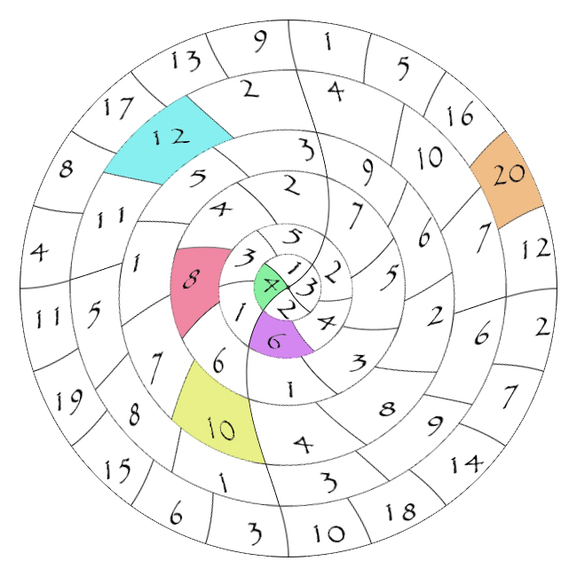

For best result cut out the figure after printing and paste it on a circular piece (of carton).

